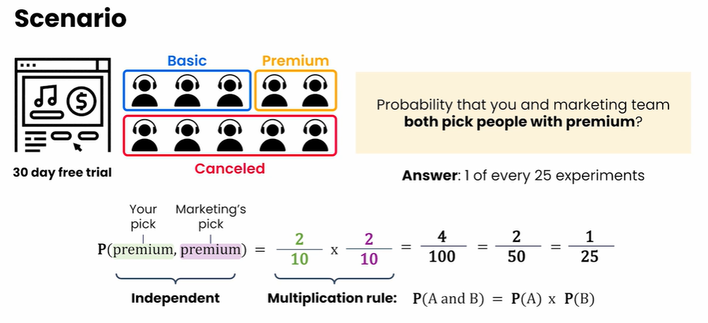
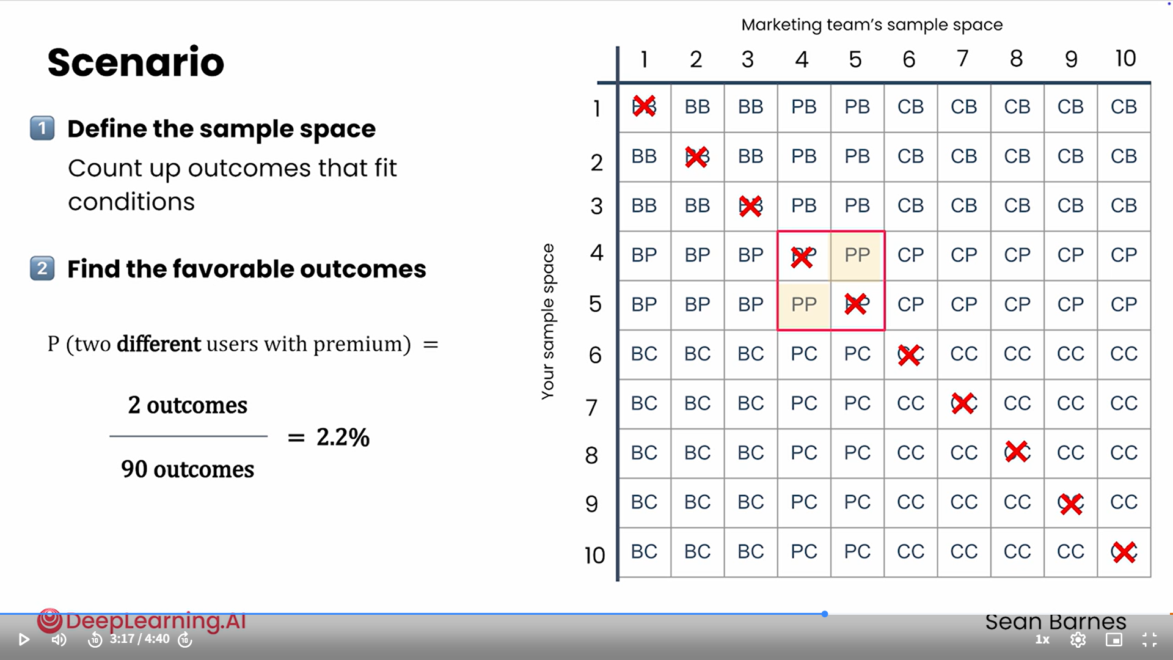
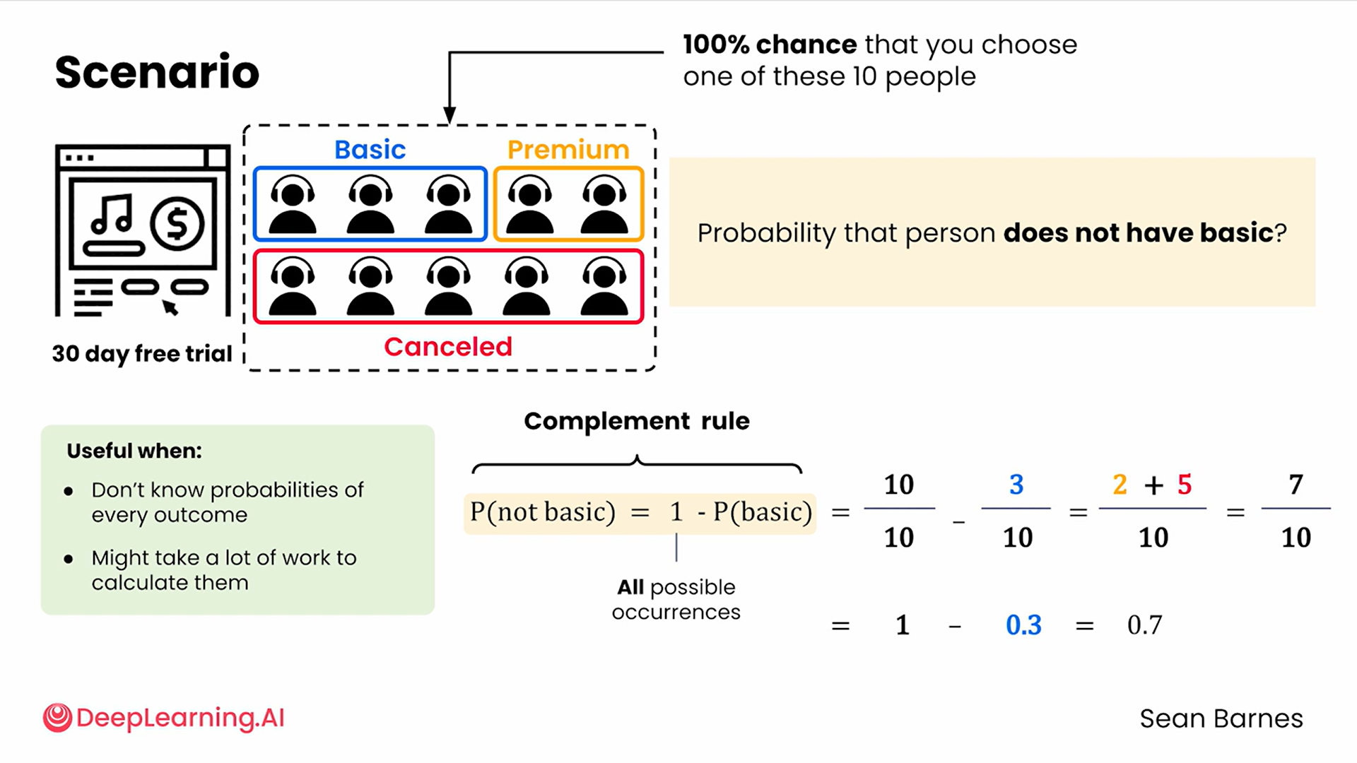🧠: Probability Rules — Multiplication & Complement

🎯 Goal
Understand how to calculate the likelihood of:
- Two events occurring together.
- The opposite (complement) of an event occurring.

📦 Scenario Setup
- There are 10 customers:
  - 3 Basic
  - 2 Premium
  - 5 Canceled
- You and the marketing team each choose one random customer to interview.

🔹 1. Multiplication Rule — Independent Events

Example: Both pick Premium users
- Your probability = ( \frac{2}{10} )
- Marketing’s probability = ( \frac{2}{10} )
- Since both choices are independent, multiply them:
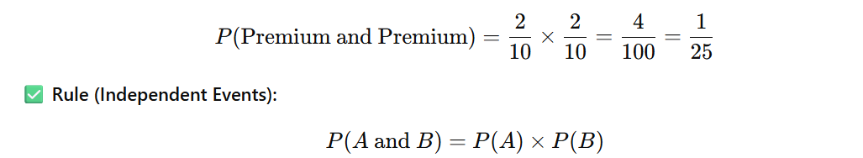
🔸 Interpretation:
Only 1 in 25 experiments results in both people having premium.

🔹 2. Dependent Events — When Choices Affect Each Other
If you and marketing can’t pick the same person, events are not independent.
- Total possible outcomes = ( 10 * 9 = 90 ) (since one person can’t be picked twice)
- Favorable outcomes (two different Premium users) = 2
[
P(\text{two different Premiums}) = \frac{2}{90} \approx 0.022 = 2.2%
]
✅ Rule (Dependent Events):
You cannot multiply probabilities directly — one event affects the other.
Use counting (sample space) instead.

🔹 3. Complement Rule — The Opposite of an Event
Used to find probability of an event not happening.

Example: Probability of selecting someone not Basic
[
P(\text{not Basic}) = 1 - P(\text{Basic})
]
Given ( P(\text{Basic}) = \frac{3}{10} = 0.3 )
[
P(\text{not Basic}) = 1 - 0.3 = 0.7 = 70%
]
✅ Rule:
[
P(\text{not A}) = 1 - P(A)
]
🔸 Use When:
- You want the opposite of an event.
- Easier than listing all other outcomes.

📘 CHEATSHEET — Probability Rules
Rule | Formula | Meaning / When to Use | Example
Multiplication Rule (Independent) | ( P(A \text{ and } B) = P(A) \times P(B) ) | When one event does not affect the other | Both choose Premium → ( (2/10)×(2/10)=1/25 )
Dependent Events | No direct formula (must adjust sample space) | When one event depends on the other | Can’t pick same person → ( 2/90 = 2.2% )
Complement Rule | ( P(\text{not A}) = 1 - P(A) ) | To find the opposite of an event | ( P(\text{not Basic}) = 1 - 0.3 = 0.7 )
Sample Space | Total # of outcomes | All possible combinations of choices | ( 10 \times 10 = 100 ) outcomes total
Favorable Outcomes | # of outcomes that fit your condition | Use numerator to find probability | 4 outcomes where both have Premium

🧩 Quick Tips
- Independent → multiply probabilities.
- Dependent → adjust counts (sample space shrinks).
- Complement → subtract from 1.
- Always define the sample space before calculating.
- Visualization (tables, trees) helps track all possibilities.

Conditional probability

🧠 Summary: Conditional Probability

🎯 Goal
To calculate the probability of an event A happening given that another event B has already occurred.

💡 Concept
- Many real-world events are dependent, meaning the outcome of one event affects the likelihood of another.
- Conditional probability tells us:
“Given that B has happened, what’s the probability that A happens?”

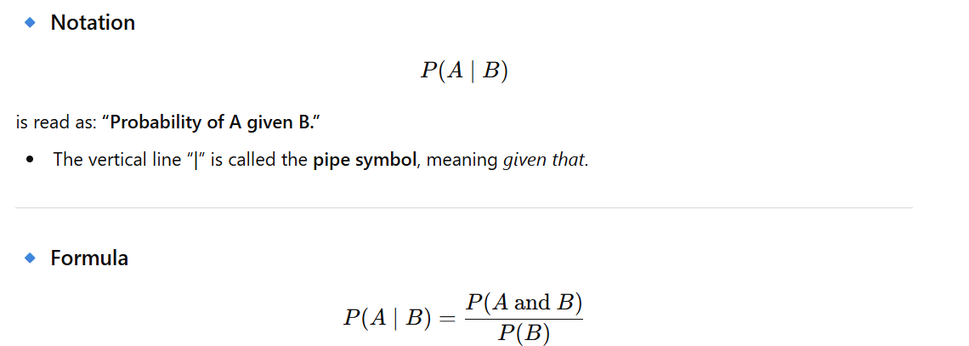
✅ Explanation:
- Numerator → Probability that both A and B occur
- Denominator → Probability that B occurs

🧮 Example: Premium Subscribers
Category | Count | Probability
Basic | 3 | 0.3
Premium | 2 | 0.2
Canceled | 5 | 0.5
Total | 10 | 1.0
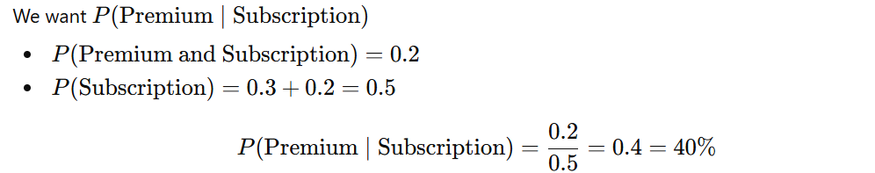
✅ So, 40% of subscribers chose Premium.

🔹 Important Distinction
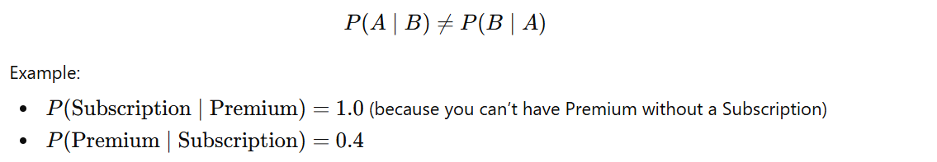

🧩 Segmentation Connection
Conditional probability is the mathematical foundation of data segmentation:
- You analyze a subset (segment) of data given a certain condition.
- Example: Average revenue per customer given they are Premium users.

📘 CHEATSHEET — Conditional Probability

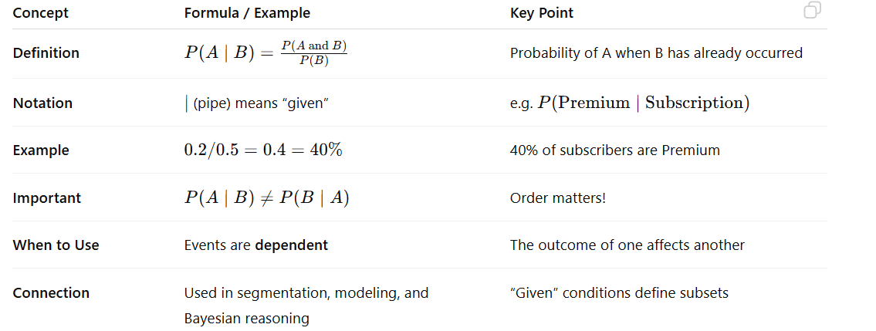

🧠 Quick Tips
- Always identify given condition (B) first.
- Check if events are independent — if not, use conditional probability.
- Draw a tree diagram or flowchart to visualize dependencies.
- Think of it as zooming in on part of your data (the “given” subset).

Independent
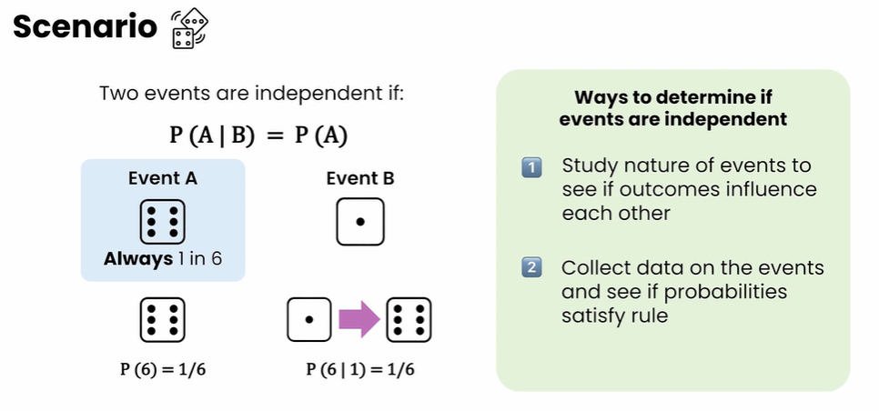
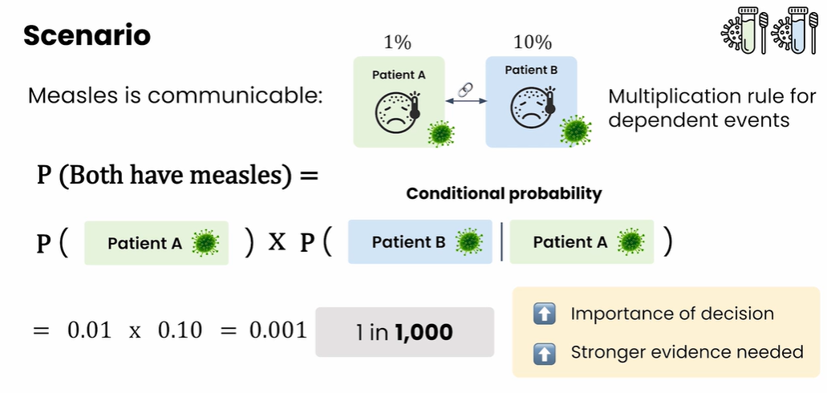
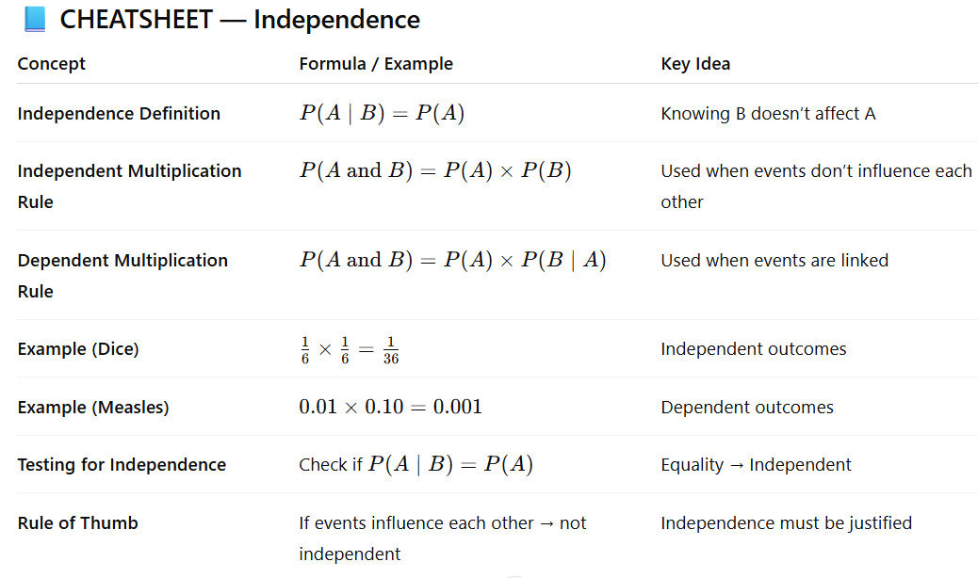
Random variables Nov 5, 2025
This content focuses on the concept of random variables and their role in representing outcomes of random phenomena.
Understanding Random Variables
- Random variables represent all possible outcomes of an event, such as the number of rainy days in a week.
- They can take on multiple values, unlike traditional variables that have a single value at a time.
Types of Random Variables
- Discrete random variables have a countable number of distinct values (e.g., number of rainy days).
- Continuous random variables represent ranges of values (e.g., total rainfall in centimeters), allowing for infinite possibilities between two values.
Probability and Random Variables
- The random variable itself does not contain probability information; it only represents possible outcomes.
- Understanding the distinction between the values of a random variable and their associated probabilities is crucial for data analysis.

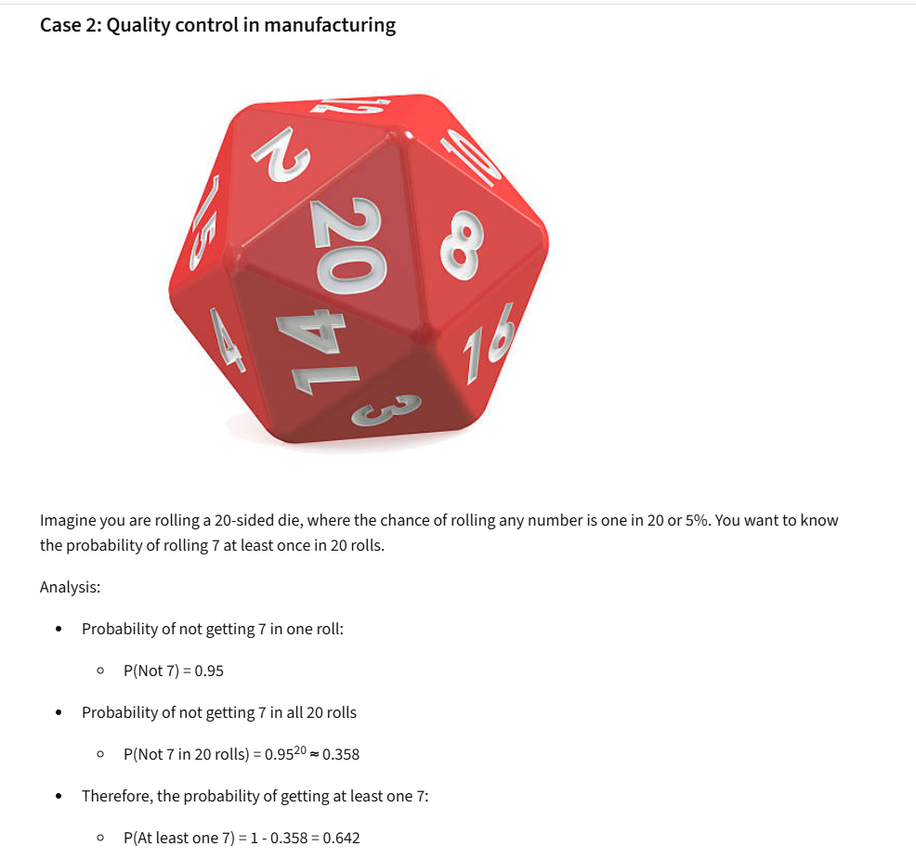

Case 3: Product choices in a cafe
Now imagine you are rolling a six-sided die, where the probability of it landing on any of the sides is 1/6. You want to know the probability of rolling 5 or 6 at least once in 10 rolls.
Analysis:
- Probability of rolling 5 or 6 in one roll:
  - P(5 or 6) = P(5) + P(6) = 1/3
- Probability of not rolling 5 or 6 in one roll:
  - P(Not 5 or 6) = 2/3
- Probability of not rolling 5 or 6 in 10 rolls:
  - P(Not 5 or 6 in 10 rolls) = (2/3)¹⁰ ≈ 0.017
- Therefore, the probability of rolling 5 or 6 at least once:
  - P(At least one 5 or 6) = 1 - 0.017 = 0.983
Why does this matter? Imagine you are a cafe manager selling fresh croissants that must be sold the same day they're baked. Based on sales data, each customer has a 1 in 3 chance of ordering a croissant with their coffee. With just one croissant left, you want to know the probability of selling it before closing, if you expect 10 more customers. This probability is the same as rolling a 5 or 6 on a six-sided die, if you roll it 10 times.
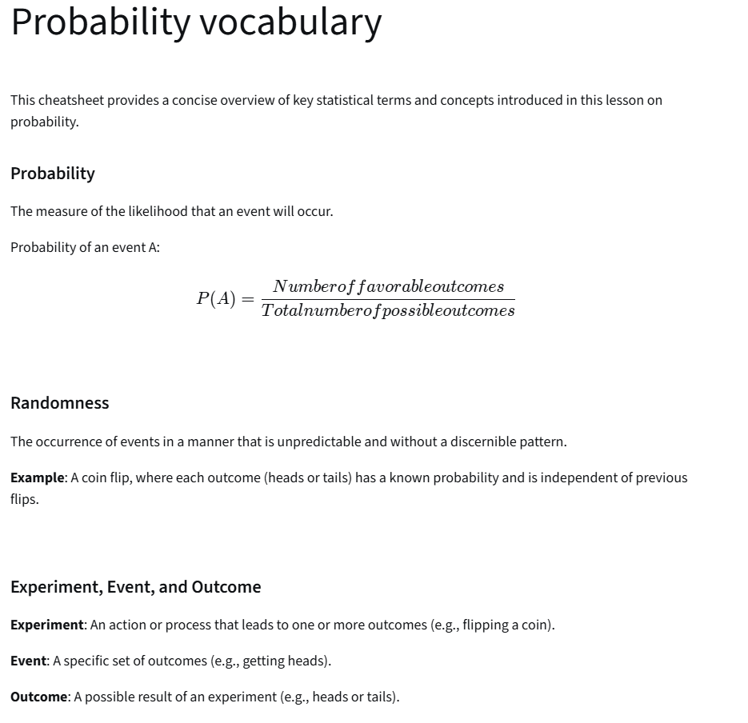
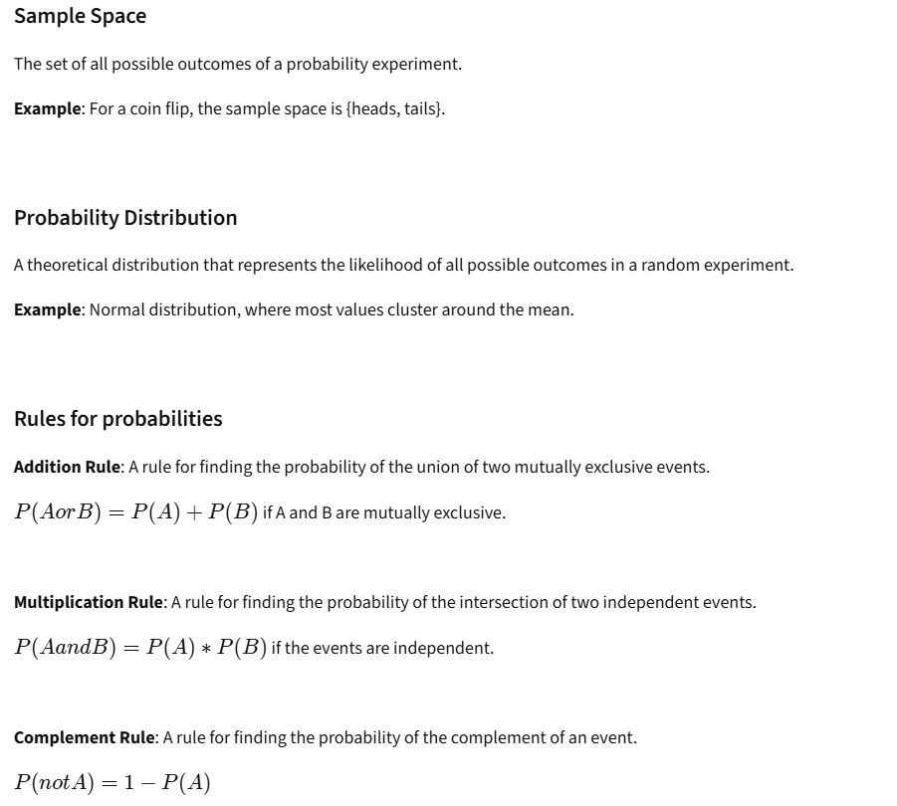
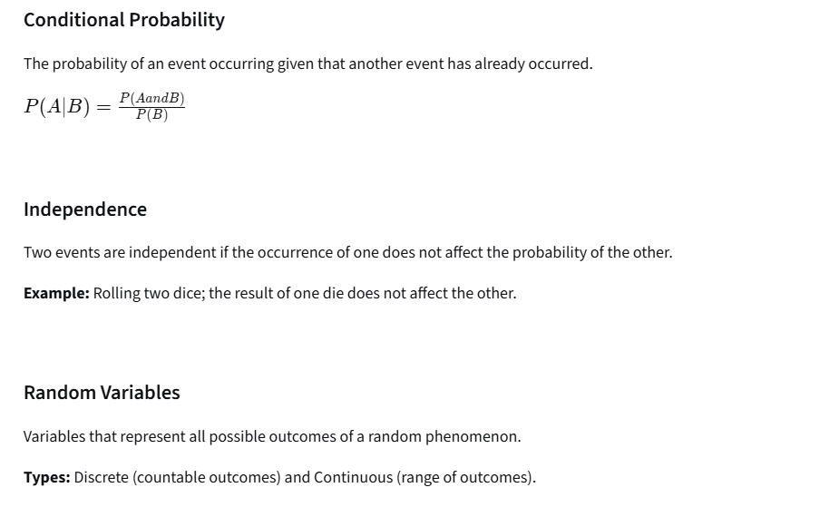

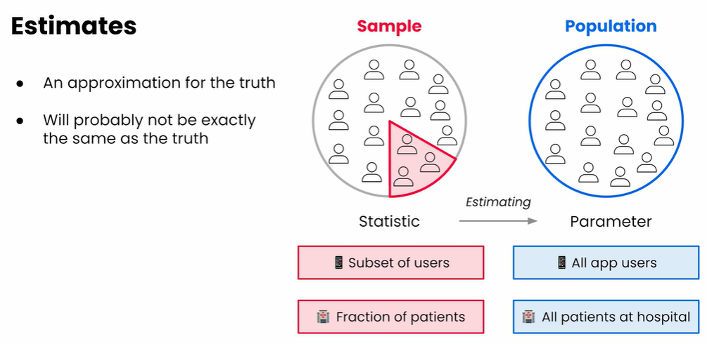

📌 Short Summary
When analyzing data, always identify whether you're working with a population (data from every member of a group) or a sample (a smaller subset of that population). In most cases, you work with a sample, and any statistic you calculate (mean, standard deviation, etc.) is only an estimate of the true population value, called a parameter.
Statistics from samples naturally include uncertainty, meaning a different sample could lead to slightly different results. Some formulas, such as standard deviation, differ depending on whether you're using a sample or a population. Your goal as a data analyst is to make the best possible inference about the population using your sample, while being aware of potential bias in how the sample was collected.
In short:
You use sample data to estimate population truths — and success depends on good sampling and understanding uncertainty.

From sample distributions to population distribution

📌 Cheat Sheet: Probability Distributions (Short + Exam-Ready)
Concept | What it Means | Key Terms | Quick Visual/Example
Random Variable | A variable whose value is based on chance. Can be discrete or continuous. | Discrete = countable values (0,1,2…); Continuous = infinite values (0–∞) | Rainy days per week (0–7) = discrete; Rainfall in cm = continuous
Probability Distribution | Shows how likely each value of your random variable is. | Probability = 0 to 1 and all probabilities sum to 1. | X-axis → possible values; Y-axis → probability
PMF (Probability Mass Function) | Probability distribution for discrete random variables. Assigns a probability to each individual value. | ( P(X = x) ) | Example: Rainy days per week → bars/columns
PDF (Probability Density Function) | Probability distribution for continuous random variables. Shows likelihood using a curve. | Probability is area under the curve between two values. | Example: Rainfall amounts (cm) → smooth curve
Sample Distribution | Distribution based on observed data from a sample. Describes what actually happened. | Sample mean, sample sd, histogram | “In 30 days, rainfall exceeded 3 cm once.”
Population Distribution | The true distribution for all possible data points. Usually unknown — we estimate it. | Parameter (true mean, true sd) | “4% chance of rainfall ≥ 3 cm on any day.”
Goal of Statistics | Use your sample distribution to estimate the population distribution. | Estimation, inference | Sample avg. ticket spending = $123 → estimate average population spending

🚀 Key Ideas to Memorize
- PMF → bars → discrete values
- PDF → curve → continuous values
- Sample statistics estimate population parameters.
- Sample ≠ population. You infer from sample → population.
Your sample is a window into the truth — but the window is never perfectly clean.

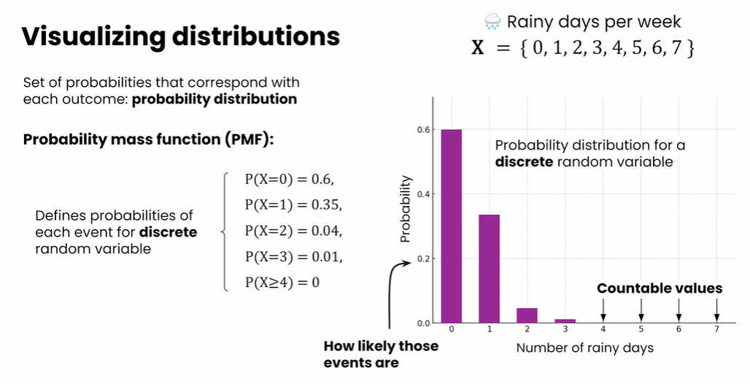

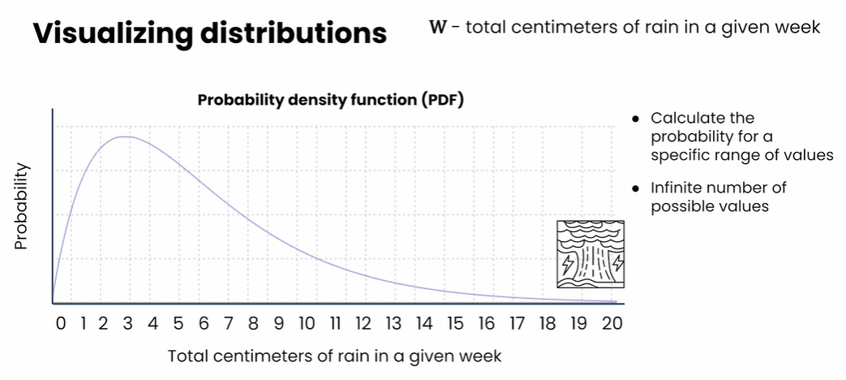
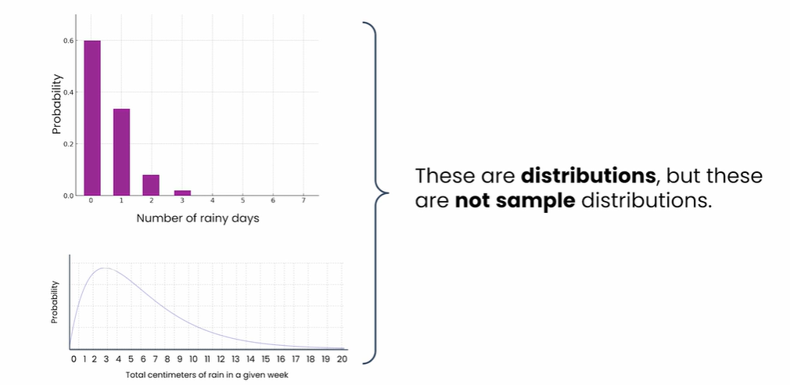
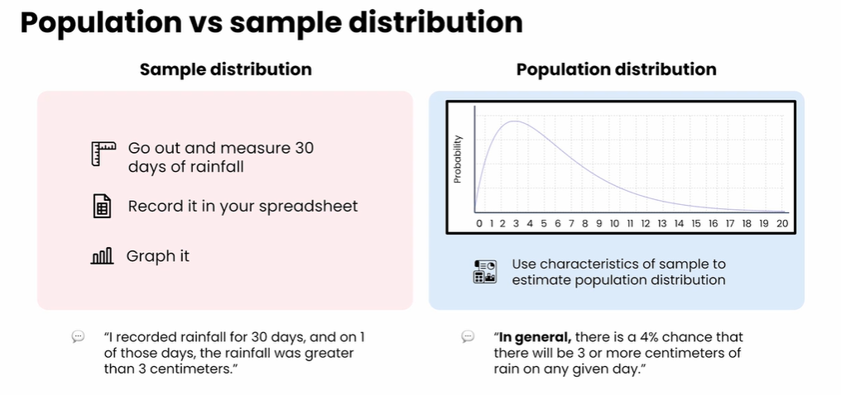

The Bernoulli distribution
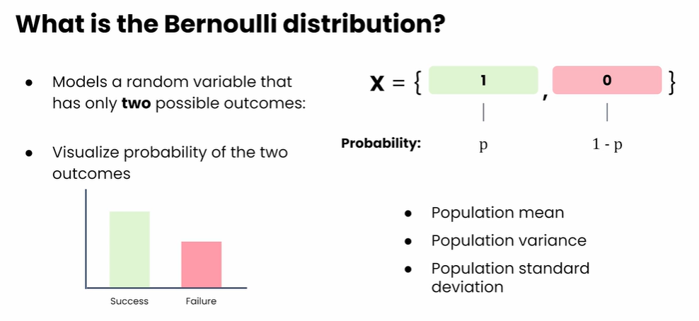

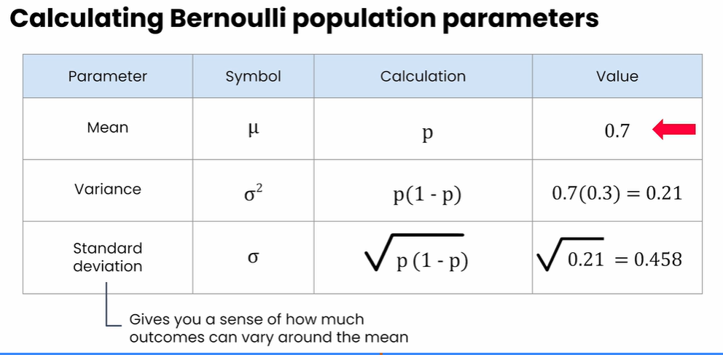

Bernoulli Distribution — Quick Cheat Sheet
(short + exam-friendly + includes tiny Python snippet)

✅ What is it?
The Bernoulli distribution models a situation with exactly two possible outcomes:
Outcome | Value | Probability
Success | 1 | ( p )
Failure | 0 | ( 1 - p )
Uses the complement rule:
( P(\text{failure}) = 1 - P

✅ When to use it
Use Bernoulli when:
- There are two outcomes (e.g., valid vs. invalid sample)
- Probability of success stays constant across trials
Example:
A DNA test lab states 70% of samples are valid
→ ( p = 0.7 )
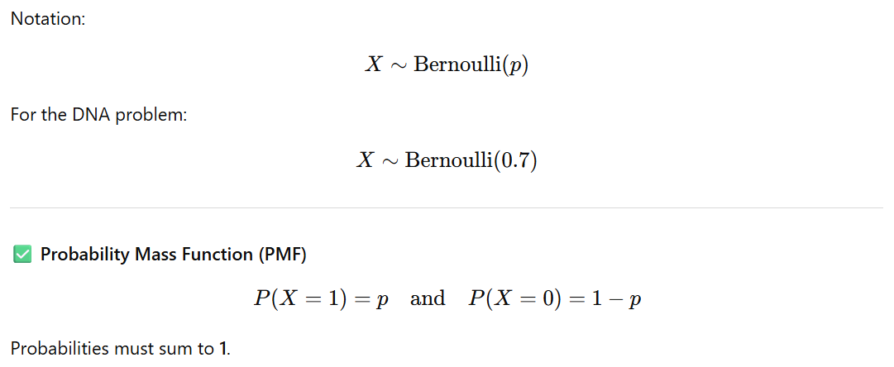

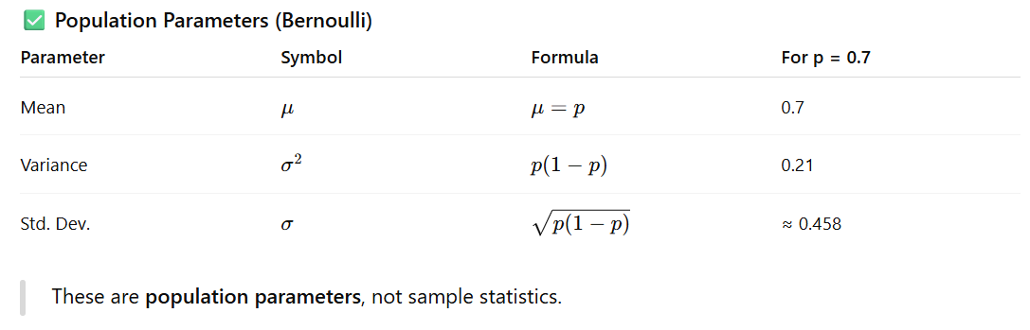

✅ Mini Python Example (PMF chart)
import matplotlib.pyplot as plt

p = 0.7
plt.bar([0, 1], [1-p, p])
plt.xticks([0, 1], ["Invalid (0)", "Valid (1)"])
plt.title("Bernoulli Distribution (p = 0.7)")
plt.ylabel("Probability")
plt.show()

🔁 Connects to Binomial Distribution
Bernoulli models one trial.
Binomial models multiple Bernoulli trials (e.g., 10 DNA kits → how many valid?).

